|  |  |  |  |  |  |  |  |  |  |  |  |  |  |  |  |  |  |  |  |
| --- | --- | --- | --- | --- | --- | --- | --- | --- | --- | --- | --- | --- | --- | --- | --- | --- | --- | --- | --- |
| **INTERSTATE CONTAINER CORPORATION** | | | ***Date:* 10/16/2014** | ***Spec #:*** | | | | | | | | | | ***Design #:* 141086-01_B** | | | |  |  |
|  |  |
| ***Customer:*** | **DeMet's Candy** |  |  |  |  |  |  |  |  |  |  |  |  |  |  |  |  |  |  |
|  |  |  |  |  |  |  |  |  |  |  |  |  | ***Cut*** | **157 in.** | |  |  |
|  |  |  |  |  |  |  |  |  |  |  |  |  |  |  |
| ***Description:*** | **RSC.611/1** |  |  |  |  |  |  |  |  |  |  |  |  |  |  |  |
|  |  |  |  |  |  |  |  |  |  |  |  |  | ***Crease*** | **107 in.** | |  |  |
|  |  |  |  |  |  |  |  |  |  |  |  |  |  |  |
| ***Style:* RSC** |  | ***Revision Info:* [B]10/16/2014:Added 1/8" to Width Per Customer Request** | | | |  |  |  |  |  |  |  |  |  |  |  |
|  |  |  |  |  |  |  |  |  |  |  |  |  |  |  |
|  |  |  |  |  |  |  |  |  |  |  |  |  |  |  |
| ***I.D. :* 11+5/16 x 7+1/2 x 8+3/16** | | ***Blank size:* 16 x 39+3/8** | ***Salesperson:* Dennis Bethem** |  |  |  |  |  |  |  |  |  |  |  |  |  |  |  |  |
|  |  |  |  |  |  |  |  |  |  |  |  |  |  |  |  |
| ***Board:* 32 B K** |  | ***Combination:* 35HP - 23M - 35HP** | ***Designer:* Brian Romankow** | |  |  |  |  |  |  |  |  |  |  |  |  |  |  |  |
|  |  |  |  |  |  |  |  |  |  |  |  |  |  |  |

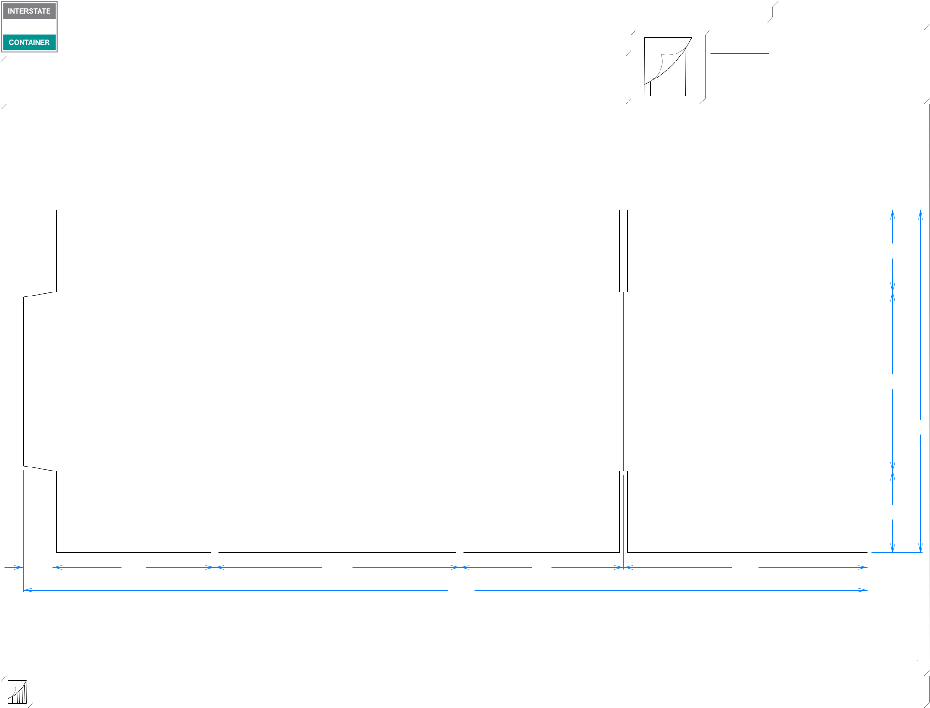

MINI FFG

313*/*16

83*/*8

16

|  |  |  |  |  |
| --- | --- | --- | --- | --- |
|  |  |  |  | 313*/*16 |
| 13*/*8 | 79*/*16 | 117*/*16 | 75*/*8 | 113*/*8 |
|  |  |  | 393*/*8 |  |

**inside view**

**Vertical Corrugation**

***notes:***

***Qty/unit:*** ***Area - waste:* 4.23 sq. ft** ***Waste on blank:* 3.3%** ***Piece weight - waste:* 0.44 lbs./197.87 g**